Clearone Midi Controller XML Configuration

## Clearone Communication Setup:

Setup the Clearone device in the section shown the image. Information Required is:

* Device ID
  + Can be found on the front display of the Clearone Device, or in Converge Console
* Model
  + The clearone model identifier, this is on the front panel and Converge Console, there is also a table in the [Clearone Serial Command guide](http://www.clearone.com/sites/default/files/CONVERGE%20Pro%20Serial%20Command%20Guide.pdf) found on the Clearone website
* Password
* User
  + URL  
    The url on your network that the Clearone has, make sure to set a static ip to the Clearone. A DNS name will work here as well

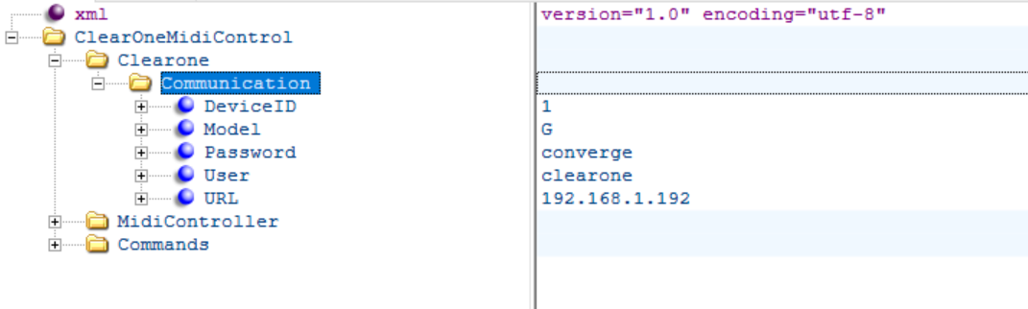

## Midi Device Setup:

The midi device settings. If the controller is connected to a device with a display, it will print the 3 midi bytes received from the control surface when an input is changed, use these bytes for configuration here. If the second and third byte are the same (usally the value), leave Param1 blank.

XML Structure shown below

* MotorENMidi
  + - The Midi command that will ‘disable motor feedback’. It actually just doesn’t send updates to the midi controller when the clearone sends changes
* MotorENMidi
  + - The Midi command the will “enable motor feedback”
  + Status
    - The First Byte received from the midi device
  + Param1
    - The second byte received from the midi device
  + Value
    - The Value received from the midi device
* MidiPorts
  + Out
    - The Out port name
  + In
    - The in Port name

If you don’t know the available port names, put something random in here, the program will output all available ports when it can’t find the port listed here. Then you will know what they are

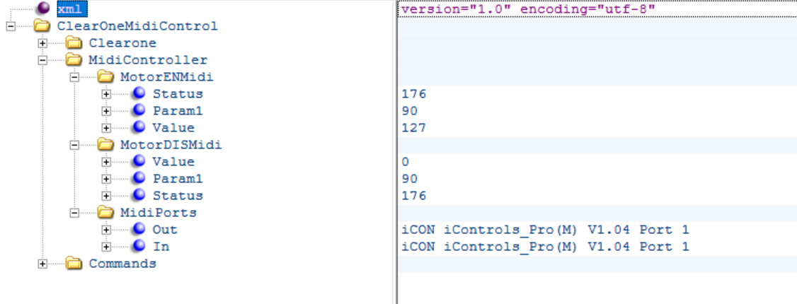

## Commands XML Configuration

This is the section where Clearone serial commands are mapped to Midi Commands produced by the midi controller. You will need to reference the [Clearone Serial Command Guide](http://www.clearone.com/sites/default/files/CONVERGE%20Pro%20Serial%20Command%20Guide.pdf) to look up the Clearone serial commands.

Currently only commands that include both the channel and group can be used, for example – GMODE can’t be used as it doesn’t have the group arguments, only channel. XGMODE can be used instead of GMODE as requires both channel and group arguments.

The value we want to change in the Clearone serial command needs to be prefixed and requires parameter so that the program recognises how to the type of Midi Control input (absolute value, incremental value, momentary button). The prefixes are:

* *v
  + Used for absolute values from controls such as Faders and absolute encoders. Format is as follows: *v**MinimumValue,MaximumValue** Example: *v-65,20 – the Minimum value the clearone can accept for the command is -65, the maximum is 20. This will be mapped to a midi range of 0 – 127.
  + *v can be used for toggle buttons; a button that alternates between sending an off then on each button press. Example: *v0,1 - This will work for a midi controler that sends a 0 for off and 127 for on.
* *m
  + Used for a momentary button; a button that sends an on signal when pressed down and an off when released. Format is as follows: *m**OnValue,OffValue** – Example *m0,1
* *e
  + Used for incremental encoders. Format as follows: *e**IncrementValue,DecrementValue,IncrementStep,DecrementStep** - Example: *e1,127,.5,-.5 – if the program recieves a midi value of 1 it will add 1 to the current value of the clearone command, if 127 is received from the midi controller .5 will be subtracted from the current clearone value.

### Setting a Gain command from a Fader on the icon i-controls Pro.

The following screenshot shows the xml settings to control the Gain on process bus A on a Clearone Converge 880TA with Device ID 0.

The Clearone serial command to change gain is (From the Clearone Serial Command Guide):

**GAIN** – Gain Adjustment

This command changes or reports back the gain for a channel.

*Command Form: DEVICE* **GAIN** <Channel> <Group> [Value] [Absol/Rel]

|  |  |  |  |  |
| --- | --- | --- | --- | --- |
| **Argument** | **Type** | **Size** | **Values** | **Units** |
| Channel | Channel | 1 | See **Groups and Channels** | - |
| Group | Group | 1 | 1, 2, 3, 5, 7, 12, 16, 17, 25, 26 (I, J, O, M, P, L, F, T, R, K, Z, D, U, V) | - |
| Value | Signed Float | 2 | -99.90 – 99.90 **  (Null to query in text) | dB |
| Absol / Rel |  | 0 | A = Absolute R = Relative Null = Relative |  |
|  |  |  | - |

In this example the command sent to the Clearone will be:

#HO GAIN A P *<the value to change>* A

You can see the command is structured by putting in the Device Type, Device ID, Command, Channel, Group, _1, _2

The numbered keys in the values element are the arguments that are unique to the current Clearone command.

